**Subject:** Proposed AWS Architecture Solution with Cost Estimates for Fastier's Web Application Hosting

Hi Lilly,

I hope this email finds you well. Thank you for reaching out regarding the challenges you're facing with Fastier's website performance. Our team has thoroughly reviewed your requirements and current setup, and we're excited to propose an AWS architecture solution that will address your concerns and pave the way for seamless scalability and reliability.

**Proposed Architecture Overview:**

1. **Route 53**: Route 53 will serve as the DNS routing service, directing traffic to your application and providing health checks for basic disaster recovery.
2. **Elastic Load Balancing (ELB)**: ELB will distribute incoming traffic across multiple instances, ensuring high availability and fault tolerance. It will also seamlessly integrate with Auto Scaling for dynamic scaling based on demand.
3. **Elastic Beanstalk with Autoscaling EC2 Group**: We recommend leveraging Elastic Beanstalk for deploying and managing your Python Flask application. Elastic Beanstalk provides support for Python applications, built-in autoscaling, and Blue/Green deployment capabilities, minimizing downtime during deployments and ensuring consistent performance.
4. **Amazon RDS**: Migrate your PostgreSQL database to Amazon RDS for managed database services, including high availability, automatic backups, and scalability options. This will enhance the reliability and performance of your application's database layer.
5. **Amazon S3**: Store static assets such as images, CSS, and JavaScript files in Amazon S3. By offloading the serving of static content from your application server, S3 will improve performance and reduce the load on your server.
6. **CodePipeline**: Implement continuous integration and continuous deployment (CI/CD) using AWS CodePipeline. This will automate the deployment process, allowing for faster and more reliable updates to your application.

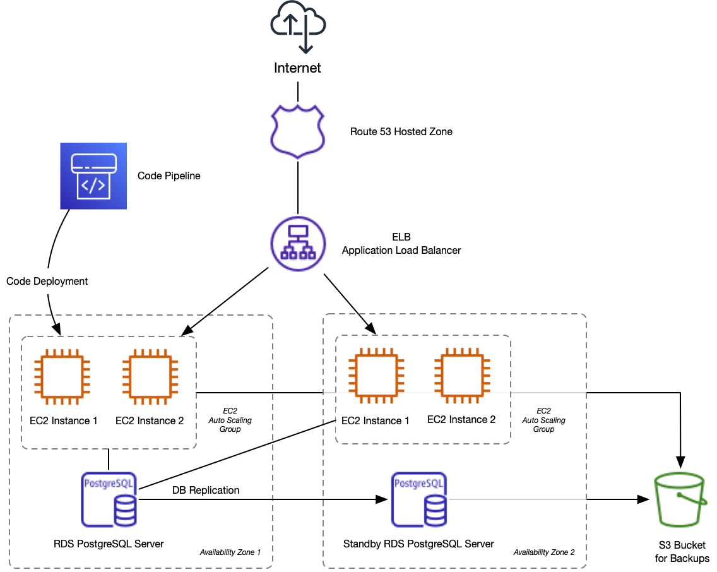

**Why This Architecture?**

* **Scalability**: Elastic Beanstalk, combined with Auto Scaling and ELB, provides the scalability you need to handle increasing traffic without compromising performance or reliability.
* **Reliability**: Utilizing managed services such as RDS for database management and ELB for load balancing enhances the reliability of your application by offloading operational tasks and ensuring high availability.
* **Cost Optimization**: While the exact costs may vary based on usage, this architecture optimizes costs by leveraging managed services and dynamic scaling, ensuring resources are utilized efficiently without over-provisioning.

**Cost Estimates:**

Here's an approximate breakdown of potential monthly costs based on typical usage scenarios:

* Elastic Beanstalk: Costs for Elastic Beanstalk primarily depend on the number of running instances and the associated instance type. Assuming usage of t3.medium instances similar to your current setup, the cost could range from $100 to $200 per instance per month.
* RDS: The cost of Amazon RDS is based on factors such as instance type, storage size, and data transfer. For a PostgreSQL database similar to your current setup, monthly costs could range from $50 to $150 or more, depending on storage requirements.
* S3: Amazon S3 costs are primarily based on storage usage and data transfer. For storing static assets and serving content to users, monthly costs could range from $10 to $50 or more, depending on storage size and data transfer volume.
* Additional costs may include Route 53 usage fees, ELB usage fees, and CodePipeline usage fees, which vary based on usage.

It's important to note that these are rough estimates, and actual costs may vary based on factors such as traffic volume, storage requirements, and specific configuration details.

**Conclusion:**

In conclusion, the proposed AWS architecture offers a scalable, reliable, and cost-effective solution tailored to Fastier's needs. While Elastic Beanstalk serves as the foundation, we remain open to exploring alternative solutions based on your specific requirements and preferences.

I'm looking forward to discussing this proposal further and addressing any questions or concerns you may have. Please feel free to reach out to schedule a meeting to dive deeper into the details.

Kind regards,

Bhaskar Banerjee

Solutions Architect